
  - September / October 2022
Welcome
Welcome to the 5th edition of our bi-monthly, Alpine Cooling Newsletter
In this edition we have a spotlight and extensive insight on our huge Toyota 4wd range of Landcruisers, Prados and Hilux’, we have some goss from the warehouse, we are looking forward to the Capricorn Gala Night and Trade Show, also a new promo to help your bottom line, and as always, some fun facts to have a giggle about!
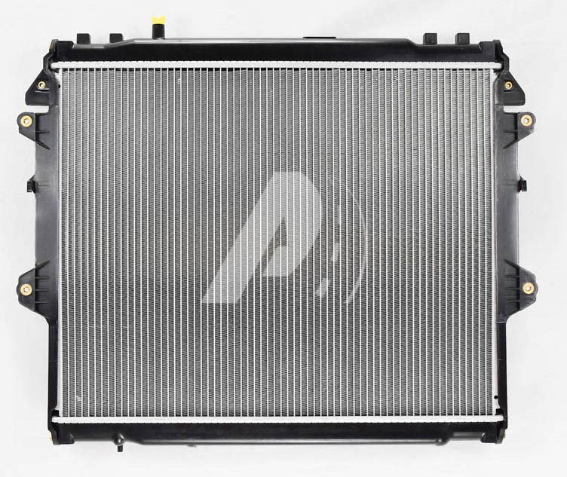
The Hilux KUN26 3.0Ltr Diesel is our most common Hilux radiator

TOYOTA 4wd range
Did you know that Alpine Cooling carry over 20 Hilux models, 16 Landcruiser models, and 8 Prado model radiators?
They are quite easy to identify on our website just by using the abbreviated model name. So, in the Hilux range for example all you need to enter is RZN or TGN, KUN [which is our most commonly sold radiator – see picture in bottom left corner], right up to the latest GUN models.
In the Landcruiser range it is easiest to type in the series, and if it is petrol or diesel, and that will drill down to the range available, for example, “80 series petrol” or FZJ “200 series diesel”, but you can also just enter FZJ, or UZJ, VDJ, or HDJ etc
And in the Prado range it is even easier again, just type in the model name, again for example GRJ or KZJ, or KDJ etc, any of the models will then bring up those options.
More importantly we have them all in stock, on the shelf and ready to go, and as always at super competitive prices!!!
With over 20 Hilux models, 16 Landcruiser models and all 8 Prado models, all in stock - we’ve got you covered!!!
Of course we also carry the whole RAV4 range, the Kluger radiators, the Tarago/Estimas and of course, ALL of the ever popular Hi Ace range – this is all on top of the Toyota passenger car range too, with over 10,000 units in stock at any time, we aim to have every vehicle that you will need, especially heading into the upcoming warmer weather!
Capricorn Trade Show and Annual Gala Dinner
Save the date; Saturday 8 October is the biggest Capricorn event of the year! We will of course be represented at the trade show from 3.00pm – 6.30pm and following that attending the Gala Dinner. We will have three staff manning our stand and look forward to showcasing some of our prducts. We love the opportunity to meet more Capricorn customers from all over South East Queensland and Northern NSW. Will you be attending? Look out for us and be sure to come say hello!
Some warehouse news;
In August we accepted another 970 units from our latest 40’ container. It topped up a lot of existing stock, brought back in some items we had sold out of, and introduced a few new products including the new CX5 Diesel radiator and some Subaru evaporators. We are expecting another 3 containers throughout September and October – yes that’s over 2,700 more units – this will prepare and steady us for the busiest time of the year. This will also include around a dozen highly anticipated new parts too – so watch this space!!!
Promotion Time;
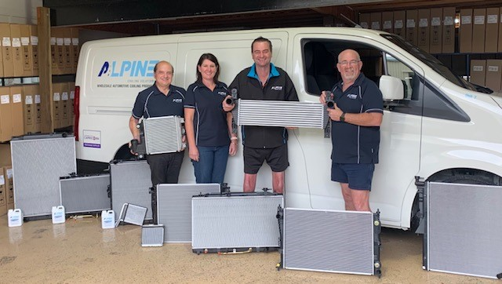
Tap here to add a caption

Before we get to the September/October offer, a quick shout out to all of those who supported us and made purchases in July and August and gained entries into the draw. Huge congratulations goes to ther lucky winner of the weekend getaway; Anything Mechanical at Nerang. We are so pleased to be able to send Daniel and Belinda away for a weekend to say goodbye to the winter blues! We trust you will thoroughly enjoy yourself and make the most of it so cheers to you, from all of us at Alpine.
* NEW PROMO * In September and October every purchase will get a chance to win your next 3 radiators for free!!! One lucky workshop will win their next 3 purchases on us – this will surely be a big boost to your bottom line. Another example of what we are here for, to support your business! Keep an eye out for the flyer for all details, and good luck to all
Fun Facts
Approx 66% of the work force drive to work each day. Across all states and territories, people in Queensland had the longest average commute to their place of work (16.7 km), followed closely by Victoria and Western Australia (16.2 km). However, Sydney averaged the longest time on the road, followed by Melbourne, but Queenslanders had the longest by distance/klms. One recent survey estimated the average travel time in Southeast QLD is around 67min each day…. The paradox is we all hate traffic, but the more cars on the road, then the better it is for the repair industry!!!
“I highly recommend and use Alpine Cooling, because they have high quality products, great product range and knowledge, and their customer service is exceptional” – Subi Motors, Gold Coast

